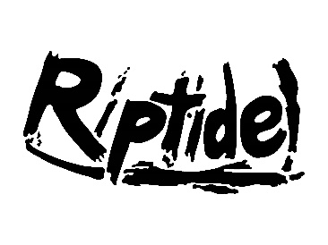
Friday Pool Set-up
Behind the Blocks
- 5-6 blue/white pop-up tents behind blocks 1-8
- Bungie cord tents together and to a bucket full of water
- Buckets should be at the points where two tents meet
- Add speakers to the tents in lanes 2, 4, 6, 8
Computer Desk
- Set-up 3 tables for the computer desk
- Clamp (red clamps) down the wood blocks for the plexiglass inserts.
- Set-up 3 white Riptide tents over the computer desk
- Secure the tents to the poles in the ground and to each other and buckets.
Snack Bar / Merchandise
- Set-up 5 tables for the snack bar, on the gravel near the side entrance.
- Set up one tent over snack bar
- Roll over BBQ (in far corner near water polo balls)
- Set up one table next to the snack bar for merchandise
- Set up another table to the right of the snack bar / merchandise for other team check-in
Dive Pool
- Rope off using rope or cation tape both sides of the dive pool so no one uses the area

